**Bucharest University of Economic Studies   
Faculty of Business Administration (in Foreign Languages)**

**Kylian Mbappé  
Performance VS Market value**

**(Descriptive and predictive analysis of how the performance of Football player effects on his Market Value)**

**IMBA students:**

**Abdallah Hatamleh**

**Dragos Bucur**

**Lia Koldelashvili**

**Bucharest, 2021**

**Table of contents**

List of abbreviation 3

1. Introduction 4

2. Data, testable assumption and Results 5

3. Conclusion 11

List of references 12

Appendix 13

Figure 1. 13

# List of abbreviation

FBP – Football player Kylian Mbapee

MV – Market Value

OS – over 4 seasons which are described and used as the data for this research

# Introduction

For the last decade, Football changed the meaning and it is considered more as a business field than just a sport. That’s why is important to analyze the data of football player’s performance to assess his Market Value. We agree that “a fair market would assign a higher market value to a player with high performance”[1].

The goal our research is: to practice our first steps into Data Analysis with Python; to analyze the career of Kylian Mbappe for his last 4 seasons, because for the past two years there is a negative trend (see the figure 1)[2] of his market value; and to predict goals for current season with the data what we are going to use in the following research.

To reach our goal we pose six basic questions: make descriptive Analysis for the players’ number of matches, Goals and assist over seasons; calculate the player's goals and assists ratio depending on the time played through the season; calculate the shot & pass accuracy; calculate the overall rating depends on goals and assists ratio & shot and pass accuracy; finally to predict expected goals for current season an make descriptive analysis of market value and overall rating.

# Methods, Data and Results

Especially in the current time it is very important to find reliable sources. For this reason, and due to the variety of data sources available worldwide, the selected data will be presented in the following. As a method to reach the goal of our research is used descriptive and predictive analysis. For the data analysis is used Python.

The market data and data of FB are taken from Transfer Market, which is a website[3] of the latest news from the world of football.

We began with import our libraries that are used on our project:

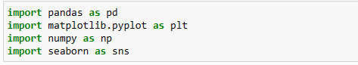

Then we import the data sheet from excel file and we used this code:



Then, we read the file and got the table and data:

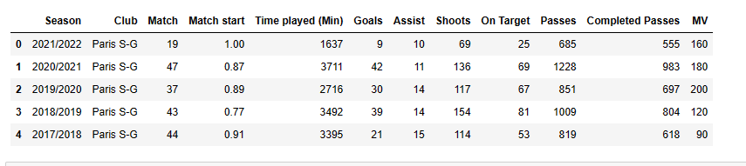

As we mentioned above we make analysis for the FB player depend on this data so, we arranged the analysis like that:

1. Descriptive analysis for his number of match, Goals, and assist over seasons

Firstly, we defined the column we wanted to use like a values:

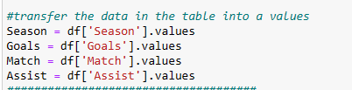

Then, we created a bar chart to show FB’s goals, assists and matches over four seasons.

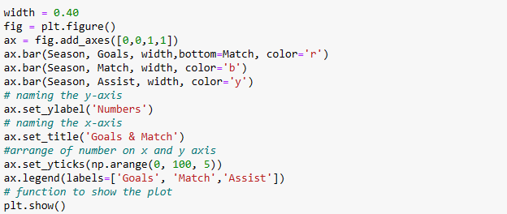

We got the result for the first question like that:

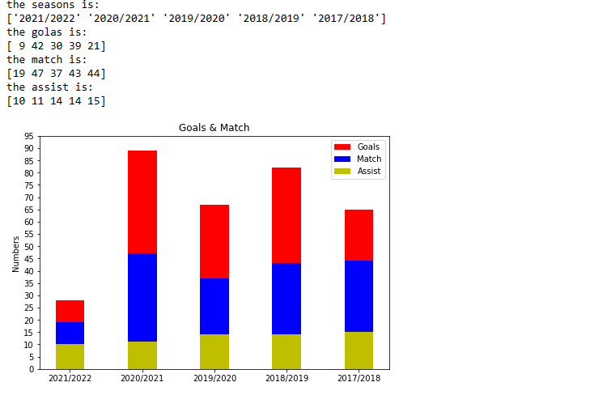

1. We calculated the goals & assists ratio over seasons because we used this ratios for calculation the overall rating and the expected goals.

Firstly, we defined “Time played” like a value to use it for calculation.

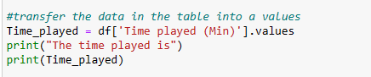

We used a formula to calculate the ratios depend on how many times FB played over seasons and transferred it to ratio per match.

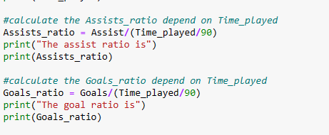

The result for this step is like that:

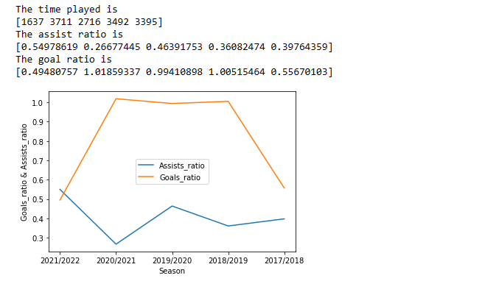

1. In step 3 we calculated the shot and pass accuracy, for shot accuracy it’s depend on goals and shot on target, and the pass accuracy is depend on how many of completed passes FB made.

Firstly, we defined the shot on target like a value, than we calculated the accuracy for shot and pass[4].

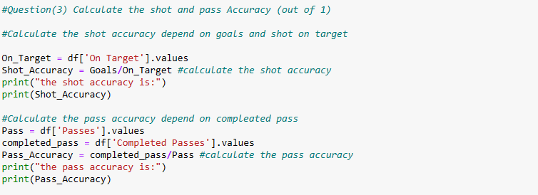

For the result of this step all values are indicated out of one (1) so, we got the result like that:

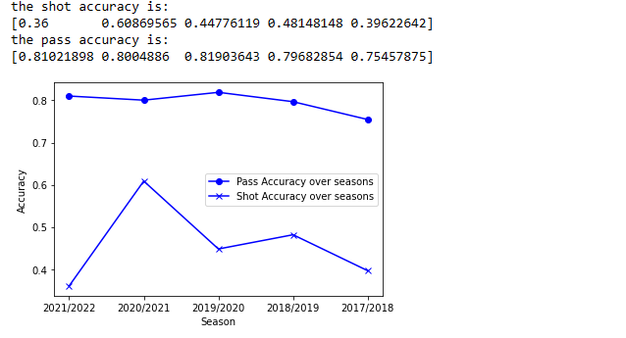

Step 4. We calculated the overall rating for the player depend on FBP’s goals, assist ratios, shots and pass accuracy.



That is the formula we used and all results is out of one (1) and the result for this step we got like that:

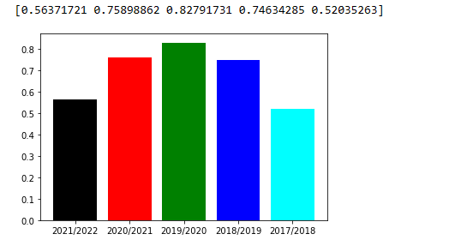

5. We calculated the expected goals for the current seasons depend on Formula we created depending on our data we used:

* Time ratio.
* Goal’s ratio.
* Shot Accuracy.
* Number of goals
* Shot on target.

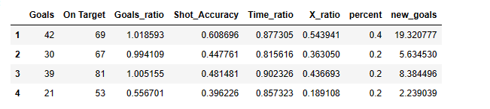

Firstly, we calculated the time ratio and defined it like a value to use it.

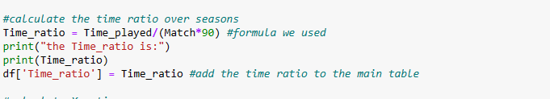

Than we calculated:

* X_ratio = Time ratio * Goals ratio * Shot Accuracy (for each season)

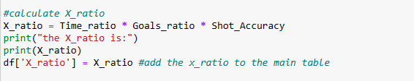

After that,

* Y ratio = (X Ratio * goals over season) + (X Ratio*shot on target over season) (for each season)

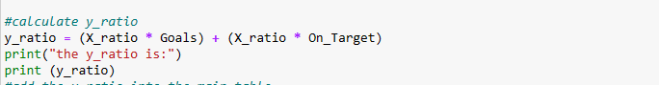

Then, we took percent of his performance for the last seasons and the previous seasons like that:

* 40% of his performance for the last season (2020/2021)
* 60% distributed on other seasons equally (2019/2020, 2018/2019, 2017/2018)

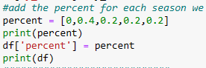

Then, we calculated the expected goals:

* New goals = ∑(Y ratio for each season * Percent of his performance)



* So, Expected goals = sum of (new goals over seasons)

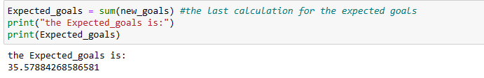

In the last step we asses his market value with his overall rating and how the market value affect through the pandemic (covid-19).

Overall rating is like that,

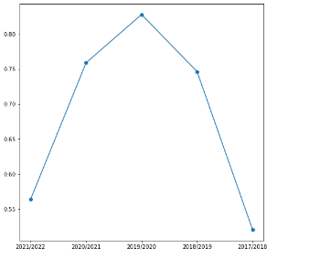

And the market value - like that:

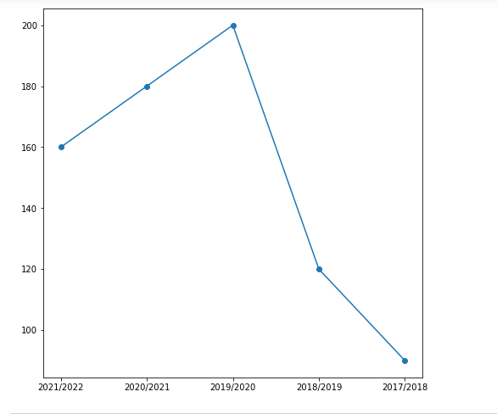

We can say from season 2017/2018 until 2019/2020 MV of FBP was increased as the rating of FBP was increased over the years, but as we notice the last two years are not depend on the rating, there is a new parameter Covid-19[5], which plays a main role on the entire football market.

During the pandemic, the purchasing power of FBP was greatly affected, as the main cause was the closures that took place in the stadiums, especially the prevention of the public from coming to the stadium. Significantly, as the club’s lack of income was not sufficient to buy a player at a high cost, which was reflected in the decline in their market value[6].

Although still boasting the highest market value of all football players, Kylian Mbappé has recorded the 2nd-highest decrease of all players since December. On one hand, FBP 15 million EUR decline in market value is due to the fact, that the contract between of FBP and PSG expires in a little over a year. On the other hand, the finances of top-level clubs were heavily impacted by Covid19, which somewhat reduces the valuation of even the most talented players as the willingness and ability to pay for “blockbuster” deals are slightly diminished. In fact, there have not been any deals with a transfer fee of above EUR 100m in recent transfer windows.

# Conclusion

As we can see, the data analysis for the players become useable and important through year because that is indicate the clubs to choose the players who fit with their team.

Though there has been much debate on the variables that influence the market value of a football player, it is clear that the number of scored goals is the best form of market value analysis for the modern football player, especially the striker. This is made evident by the fact that over the course of our paper, we demonstrated through hard data that the market value of Kylian Mbappe fluctuates on the same path as the scored goals. This type of analysis is mostly relevant for attacking players while the one playing on defend should have an analysis based on tackles and clean sheets.

# List of references

He, M., Cachucho, R., & Knobbe, A.J. (2015). Football Player's Performance and Market Value. *MLSA@PKDD/ECML*., Available at the following link: <https://bit.ly/3oSolun>

Market value of FBP is available at the following Website: <https://bit.ly/30rUob3>

The official website of Transfer market <https://www.transfermarkt.com/>

“Official! The 10 players with the best minutes-per-goal ratio in Premier League history”. Available at the link <https://bit.ly/33hKKsx>;

“Player Valuation Update: the crippling effects of Covid”. Available at the following link: <https://bit.ly/33zOMwR>;

“Player value not immune to pandemic” An analysis of the impact of the COVID-19 crisis on football players’ market values. Available at the following link <https://bit.ly/3yr8FkN>;

# Appendix

Figure 1. **MV of FB over time**

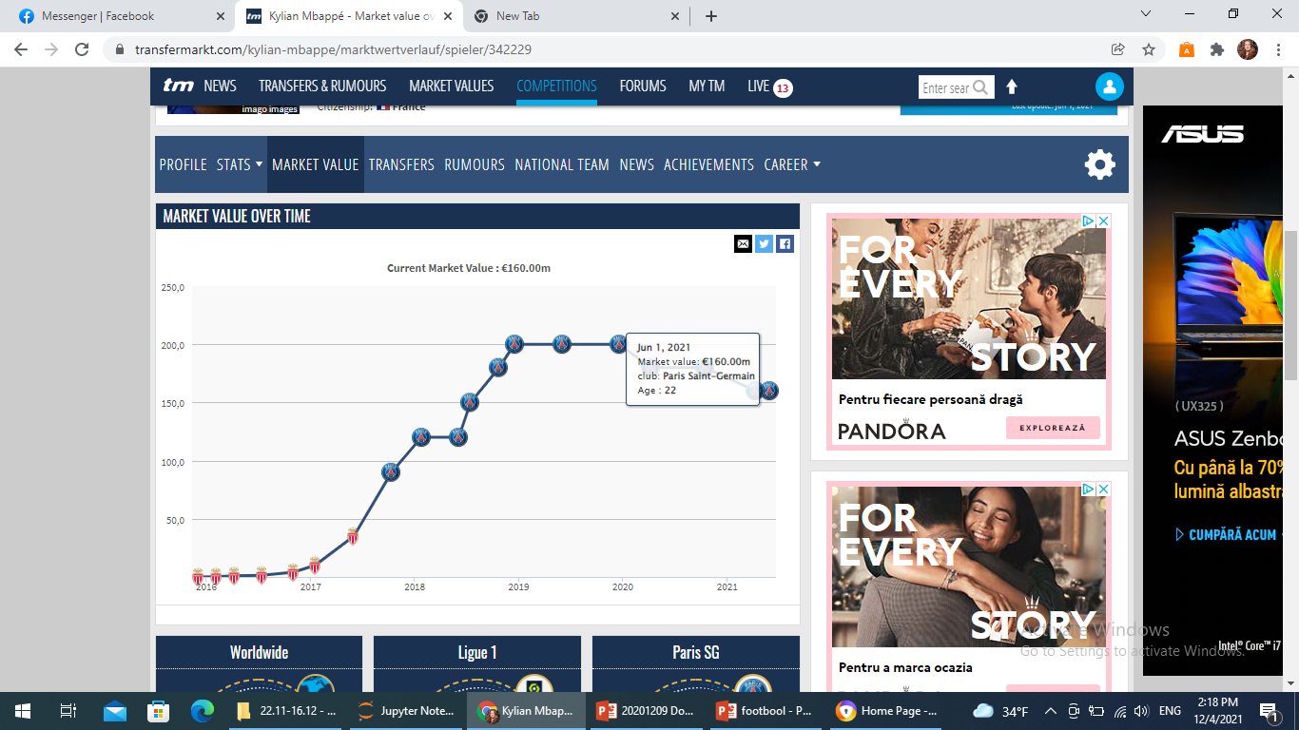

1. He, M., Cachucho, R., & Knobbe, A.J. (2015). Football Player's Performance and Market Value. *MLSA@PKDD/ECML*., <https://bit.ly/3oSolun> (Accessed on 5.12.2021 on);
2. The information is taken from the following link <https://bit.ly/30rUob3> (Accessed on 11.12.2021);
3. The information is taken from the following link <https://www.transfermarkt.com/> (Accessed on 11.12.2021);
4. Notice: to make sure the formula used is right, we read this article: “Official! The 10 players with the best minutes-per-goal ratio in Premier League history”. Available at the link <https://bit.ly/33hKKsx> (Accessed on 5.12.2021)
5. “Player Valuation Update: the crippling effects of Covid”. <https://bit.ly/33zOMwR> (Accessed on 9.12.2021);
6. “Player value not immune to pandemic” An analysis of the impact of the COVID-19 crisis on football players’ market values. <https://bit.ly/3yr8FkN> (Accessed on 9.12.2021);